Phase 4
Network Protocol attacks

Objective
The Goal of this test is to perform network level attacks on a windows host using LLMNR/NBT-NS spoofing using responder tool present in the Kali Linux. We are performing Spoofing and Man in the middle attack (MIMT) to capture NTLM Hashes and demonstrate protocol weaknesses.

Tools used
- Responder
- Wireshark
- Kali Linux VM
- Windows Host

Attack Performed
- Starting Responder on Kali
We start the responder on kali by using this command responder -I eth0.
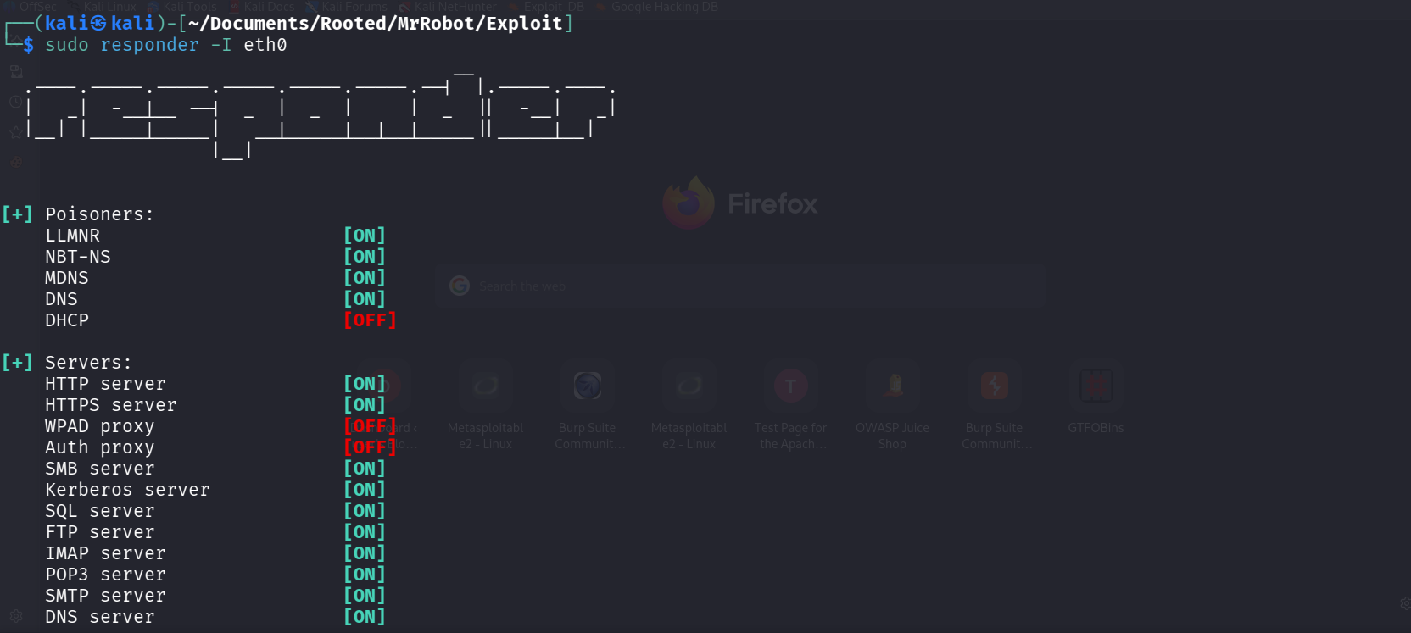

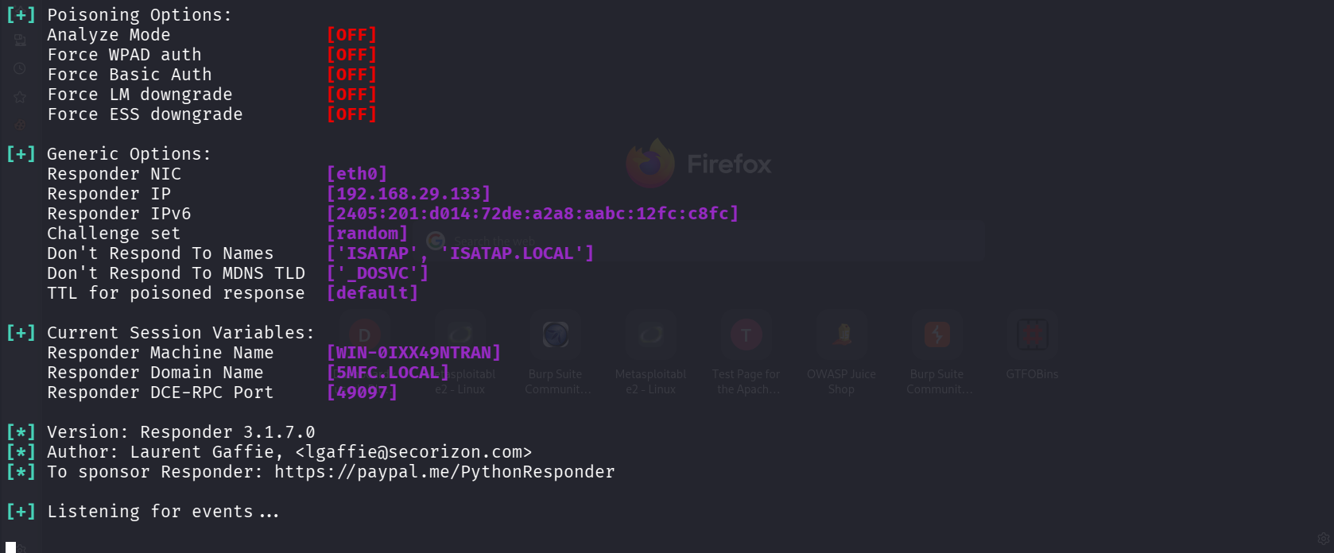
Our Responder setup is done and it is listening for events.
- The windows host attempting to access share
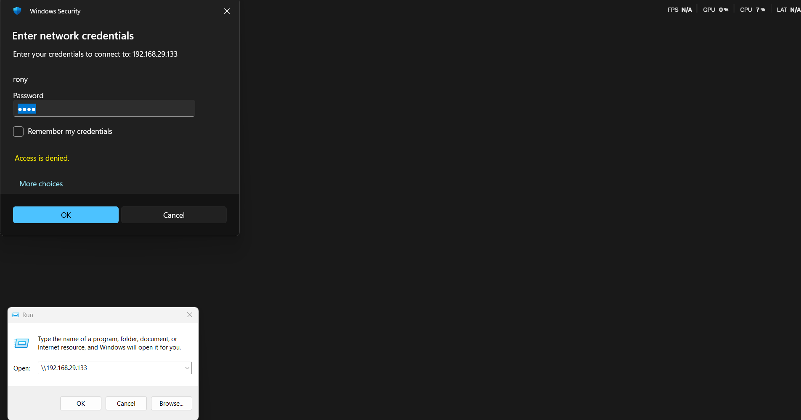
We are attempting to access a share which is nonexistent. We are performing this for the testing’s sake.
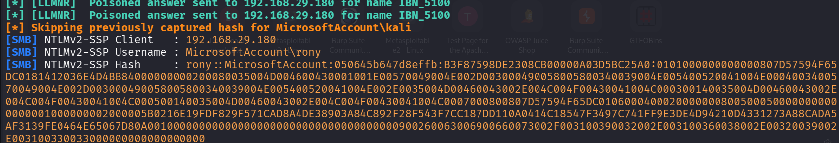
NTLM hash for rony was successfully captured.

SMB Authentication Capture
- Username: rony
- Hash: rony::MicrosoftAccount:050645b647d8effb:B3………
- Protocol: SMB over LLMNR/NBT-NS poisoning
This proves the Windows machine trusted the spoofed host a protocol misconfiguration.

Evidence Log
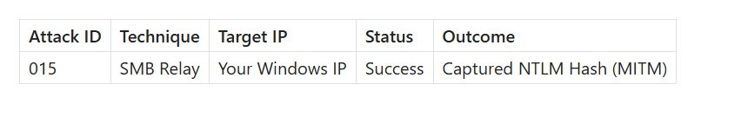
MIMT Summary
We were able to perform Man in the Middle attack (MIMT) by spoofing LLMNR/NBT-NS responses on the network using Responder. Windows host tried to access a nonexistent share on the server hosted by the Kali Linux with responder. This action actually transferred the NTLMv2 hash to the attacker allowing credential stealing.

Remediation
- Turn off LLMNR and NBT-NS on Windows.
- Turn on SMB signing
- Enforce NTLMv2 only.
- Perform DNSSEC and internal DNS hardening
- Use Kerberos instead of NTLM authentication

